
a
Company
Logotype

Cone Beam Computed Tomography- Report



Porur Dental X-rays & CBCT

Patient Name : Mrs. Rachel | Date of Report : 19.07.2024
Age/ Gender : 56 years/ Female | Region of Interest : CBCT Sectional Maxilla
Referring doctor: Dr. Anjan Kumar | Indication : Implant assessment
Clinical Notes: Nil
PATIENT INFORMATION

CBCT- Sectional Maxilla provided
CBCT – IMAGE DETAILS

RADIOGRAPHIC INTERPRETATION

- Completely missing crown and root portion in relation to 16, 17, 26, 27, 28.
- Root stumps: 18, 24, 25
- The maxillary alveolar ridge is present with normal trabecular pattern.
- In relation to 14, 15 presence of hyperdense restorative material involving the crown and extending into the pulp canal upto the middle third of the roots is evident.

IMPLANT ASSESSMENT

12 region
Sub-Crestal
Mid- Crestal
Distance between the alveolar ridge and Floor of the Nasal cavity (in mm)

RADIOGRAPHIC IMPRESSION

- Partially edentulous maxillary arch.
- Root stumps: 18, 24, 25

Kindly correlate with clinical findings


IMAGES FOR REFERENCE

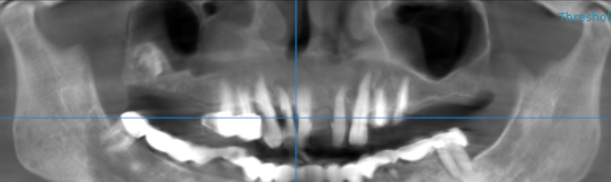

3-DIMENSIONAL VIEW

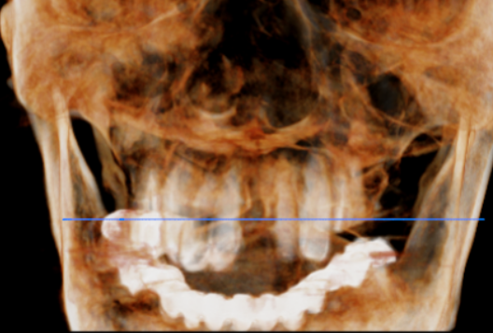

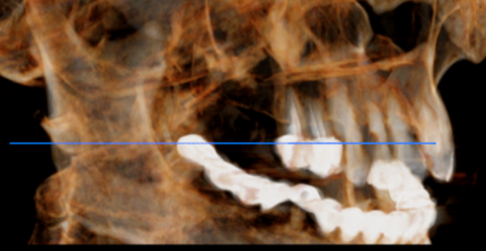
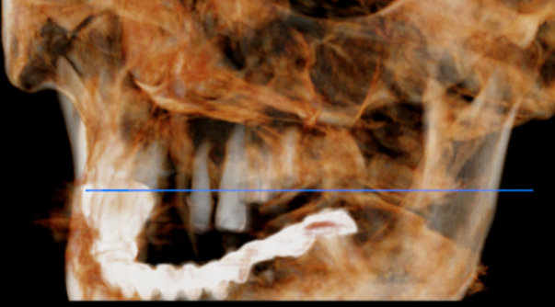

CROSS SECTIONAL VIEW

16 region | 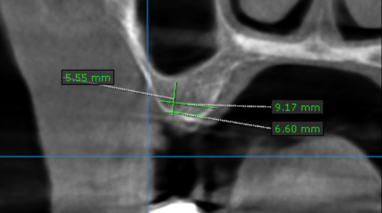
17 region | 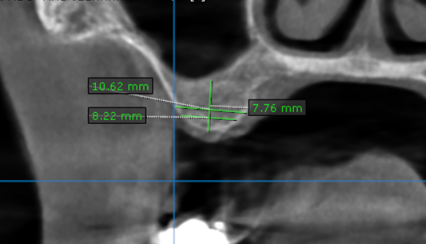
21 region | 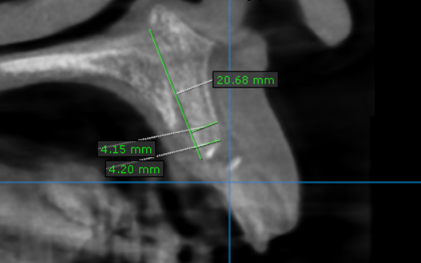
24 region | 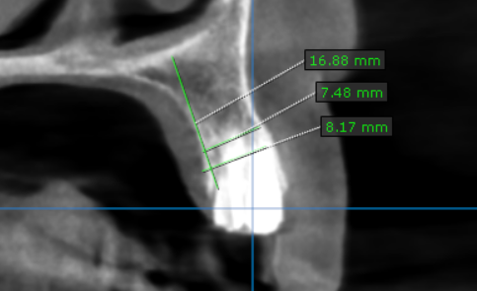
25 region | 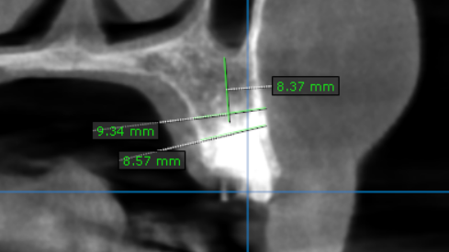
26 region | 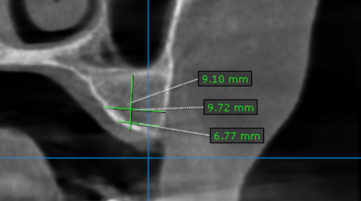
27 region | 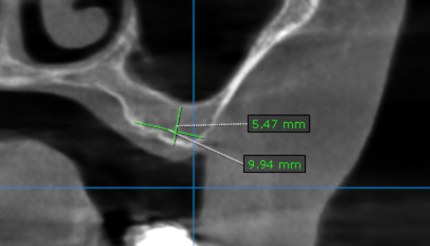

**** End of report ****

